325 Strathmartine Road, Dundee, DD3 8NE
Tel: 01382 812111, Fax: 01382 858315

We have just introduced a new online service which enables patients to order their repeat prescriptions online (easier than the current email service we offer) and also allows patients to book routine appointments online.

If you are interested in signing up for this, please complete the form below and return to the surgery.
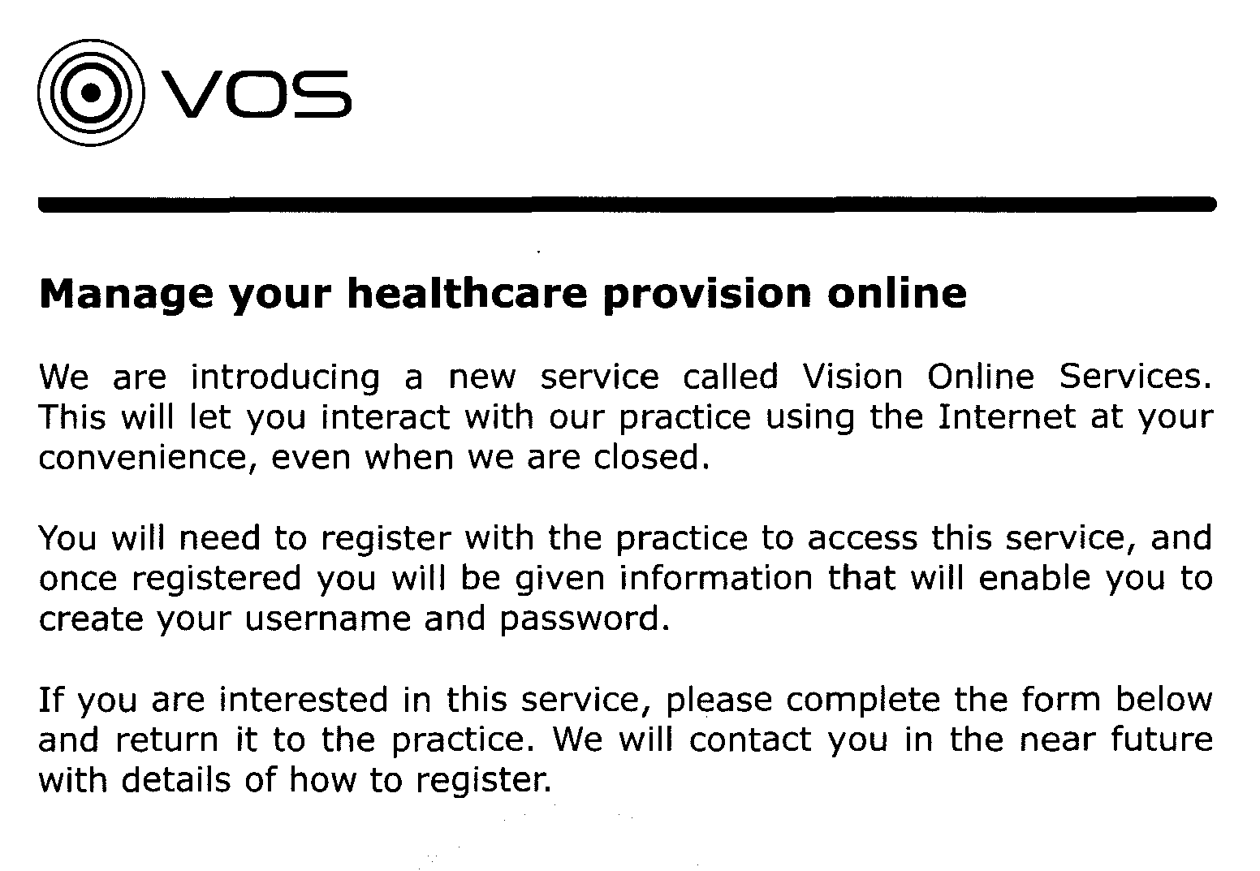

Please complete your details below:

First name: ____________________ Surname: _____________________

Date of birth: ___________________

Email address: _________________

I would like to register for Vision Online Services (please tick box) [ ]

Once complete, please email to:

Downfieldsurgery.tayside@nhs.scot or hand in to reception

